**Lab Exercise 8– Creating a VPC in Terraform Objective:**

Objective: Learn how to use Terraform to create a basic Virtual Private Cloud (VPC) in AWS.

Prerequisites:

• Terraform installed on your machine.

• AWS CLI configured with the necessary credentials.

Steps:

1. Create a Terraform Directory:

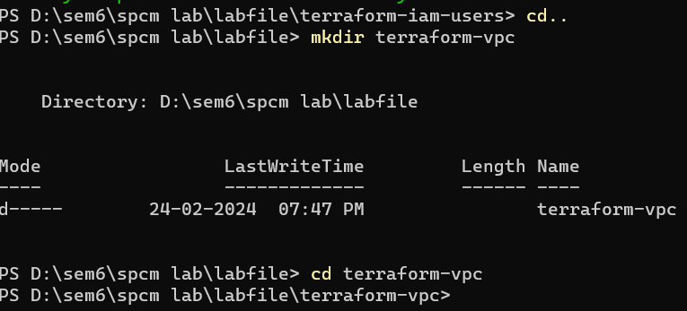

Create Terraform Configuration Files:

• Create a file named main.tf:

# main.tf

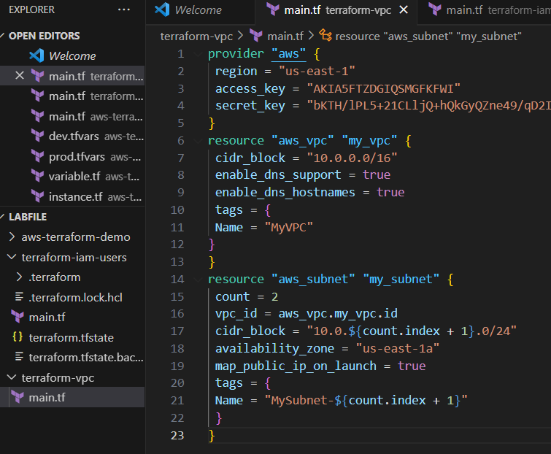

1. Initialize and Apply: Run the following Terraform commands to initialize and apply the configuration:

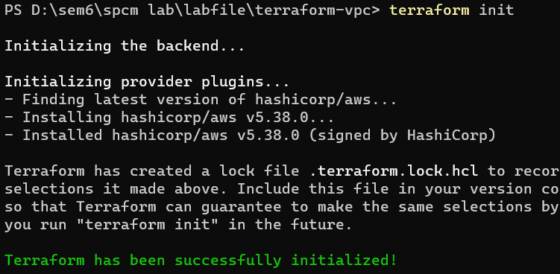

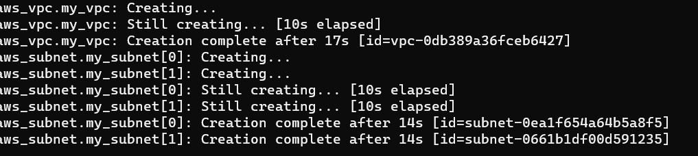

3. Verify Resources in AWS Console:

• Log in to the AWS Management Console and navigate to the VPC service.

• Verify that the VPC and subnets with the specified names and settings have been

created.

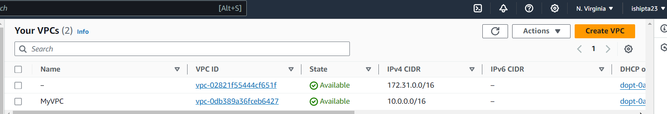

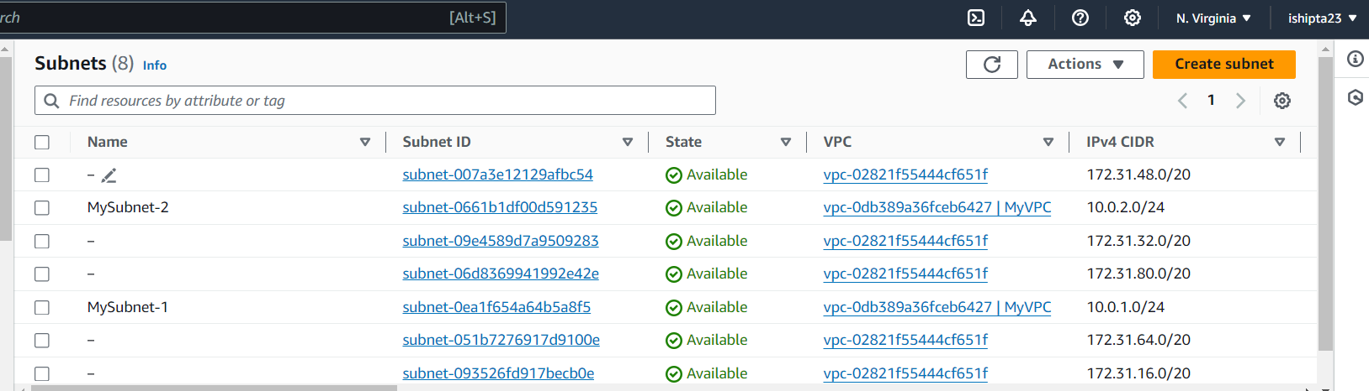

4.Clean Up: After testing, you can clean up the VPC and subnets: